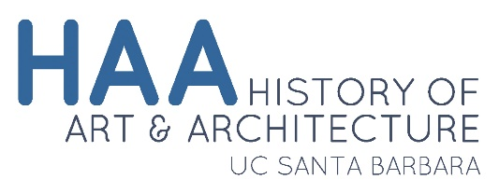 |  |  |  |  |  | Petition to Declare a Minor

Student Information
Student Name:
 |  | Last Name |  |  |  |  |  | First Name |  |  |  |  |  |  | M.I.
Perm Number: |  |  |  | Major: |  |  |  |  |  |  |  |  | Expected Graduation Date:
Phone Number: |  |  |  |  |  |  |  |  |  | Umail:

Which minor are you declaring? ☐History of Art and Architecture ☐Museum Studies
You may assume that your petition to declare a minor has been approved unless you are contacted by the department.
You will need to:
* satisfy the requirements for the minor in History of Art and Architecture or Museum Studies
* provide the undergraduate advisor with an accurate date of graduation
* provide the undergraduate advisor with documentation of ALL EAP coursework, and petition it to count towards the minor
* ALL UPPER DIVISION COURSES MUST BE TAKEN FOR LETTER GRADE*
Student Signature: |  |  |  |  |  |  |  |  | Date:
Undergraduate Advisor Signature: |  |  |  |  |  |  |  |  | Date:

For Department Use Only
 | ARTHI Course |  |  |  | Grade |  | Petition
Lower Division 1:
Lower Division 2:
Upper Division 1:
Upper Division 2:
Upper Division 3:
Upper Division 4:
AND

FOR HAA MINORS:
Upper Division 5:
OR, FOR MUSEUM STUDIES MINORS:
Internship Units:
Internship Units:
Internship Units:
* Only Museum Studies minors may take ARTHI 141B P/NP for their required internship units

