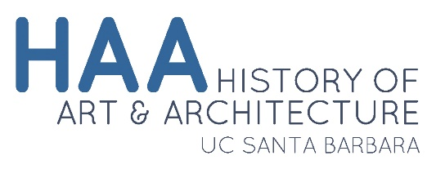 | Graduate Native Language Verification

Student Information
Please complete this form and submit it to the Academic Program Manager, Savannah Parison.

Student name: _____________________________________________________________________________

Major Area of Study: ________________________________________________________________________

Foreign Language: __________________________________

Please describe how your native language applies to your area of research:

For Department Use Only
By signing below, I indicate my approval for the application of this student’s native language proficiency to be applied to their language requirement.

____________________________________ ________________________________________
Graduate Advisor Signature Primary Thesis/Dissertation Advisor Signature

