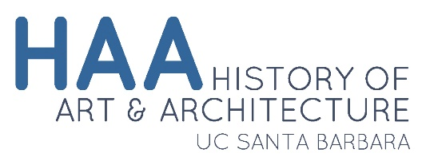 |  |  |  |  | Year End Student Progress Evaluation

Student Information
To be completed by the student and given to their faculty advisor for comment before being submitted to the Graduate Program Advisor, gd-arthi@arthistory.ucsb.edu.
Student Name: |  |  |  |  |  |  |  |  |  |  | Date:
 |  | Last Name |  |  |  |  | First Name
I. Courses I have taken this year:
Fall |  |  |  | Winter |  |  |  |  | Spring
II. One Paragraph Report on Academic Progress to be Completed by Student (Below):
III. One Paragraph Evaluation of Student's Academic Progress to be Completed by the Student's Faculty Advisor (Below):

